**Android App Document**

**(1) Welcome Screen Page**



**(2) Registration Page**

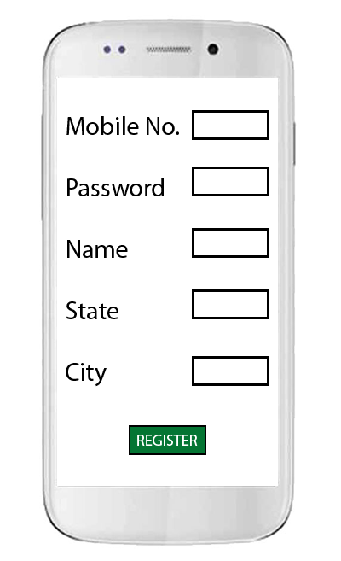

**(3) Menu Page**

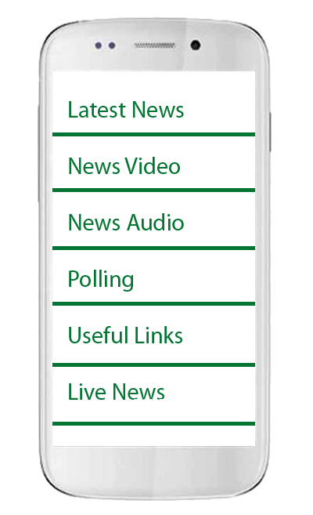

**(4) Heading Page**

1. a. After click on **Latest News** b. After click on particular News

Show Heading Page Shows Detail Page

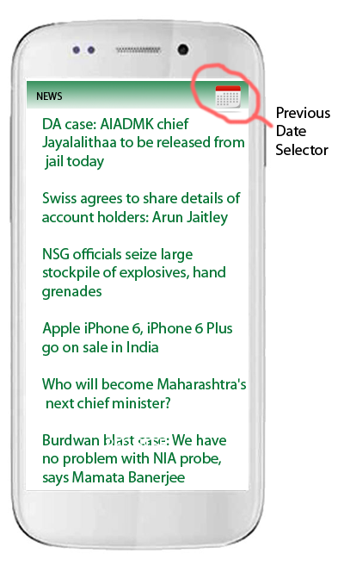 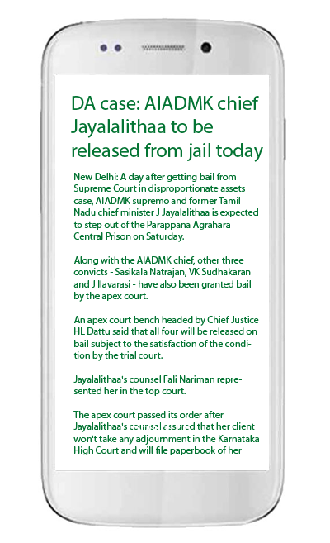

2. a. After click on **News Video** b. After click on a video

Shows heading page Shows video in full size

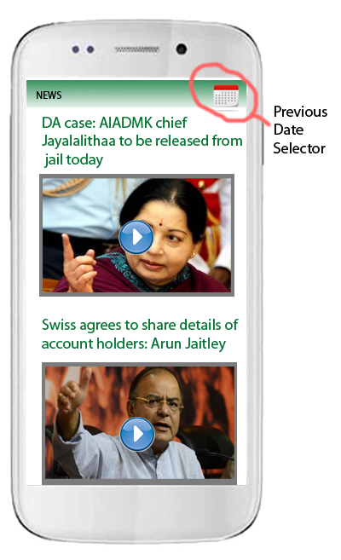 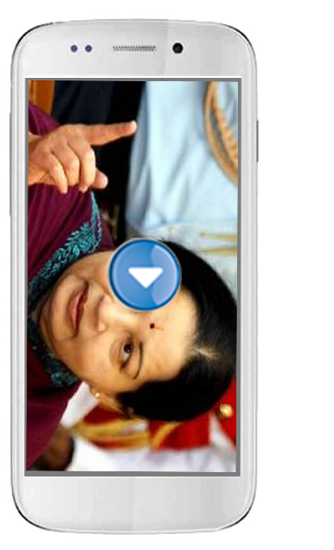

3. a. After click on **News Audio**

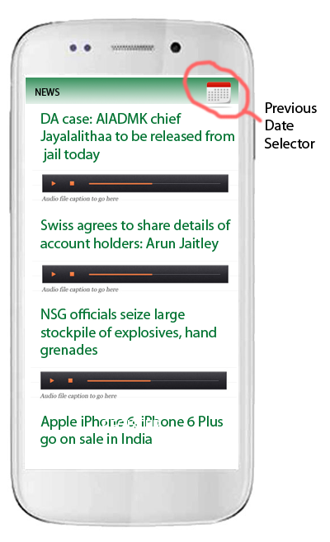

click on particular audio it will play here.

4. a. After click on **Polling**

(Shows Panel where user can poll the question)

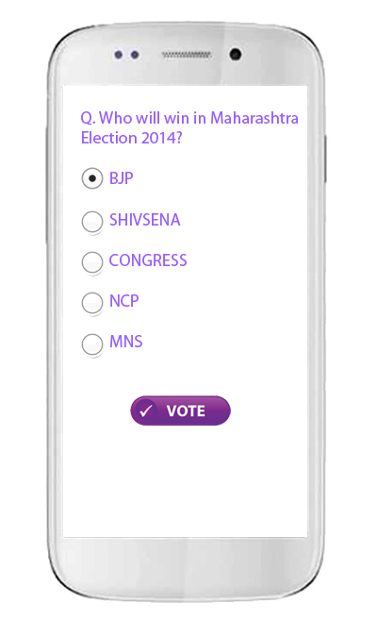

5. a. After click on **Useful Links**

(Shows heading page. After click on any link it will open in browser.)

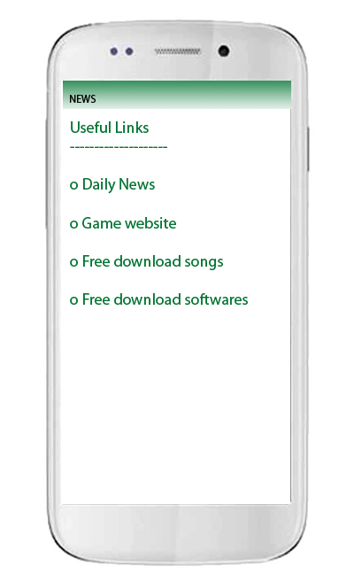

**Summary -**

---------------------------------------------------------------------------------------------

**In App** :-

(1) Total Page : 12

**In Web** :-

(1) Admin panel with login

(2) Add news

(3) Add Videos

(4) Add Audios

(5) Polling

(6) Useful Links

(7) Live News

Note :

(1) Please provide the ICON (image) for our android app.

(2) Approve as soon as possible. So that I work start early.

From Date

Yogesh Kumar Bowaria 18-oct-2014